RENEWED HOPE FOOD PANTRY & CLOTHES CLOSET  VOLUNTEER GUIDELINES  New Haven SDA Church appreciates your service as a volunteer for the ReNewed Hope Food Pantry. We will do our best to make sure your experience is rewarding. | 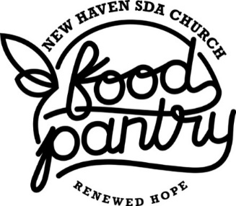

As a volunteer, you agree to:
- Serve any client
- Complete duties as requested; always ask for help when needed
- Come with clean hair, hands, and clothes; wear close toed shoes
- Wear a name badge for easy identification
- Wash hands before handling food and when returning from the restroom
- Help keep all parts of the pantry clean
- Report possible hazards or unsafe activities immediately
- Use proper lifting technique, using your legs to lift, keeping your back straight and body balanced
- Only take on tasks you are physically able to handle. Ask for help lifting or moving items.
- Be cheerful, courteous, and helpful to clients and other volunteers
- Contact the Volunteer Scheduler as early as possible if you are not able to come for your shift
- Refrain from volunteering when you are ill

Please be aware that:
Harassment of any kind is not tolerated. Behavior that creates discord or makes it uncomfortable for other volunteers to serve is not tolerated. Report cases immediately.
Anyone under the influence of drugs and/or alcohol will not be permitted to volunteer.
Smoking is not permitted.
Running, shouting and horseplay (tossing food, etc.) is not permitted.
Food and other items are available for those in need. It is not for volunteers as a thank you. Thus, food and other items must not be taken. If you need food and meet the criteria to become a client, follow procedures for clients to receive service.
Youth volunteers (ages 14-17) must have a permission slip in order to volunteer. Youth who are ages 14 and 15 must be accompanied by an adult who is 21 years of age or older.
All personal belongings should be locked in a safe space in your car or other location you feel is safe. ReNewed Hope Food Pantry assumes no responsibility for damage or loss of personal property.

I have read and understand my responsibility to follow these rules while I am a volunteer.

Volunteer Printed Name | Volunteer Signature | Date

