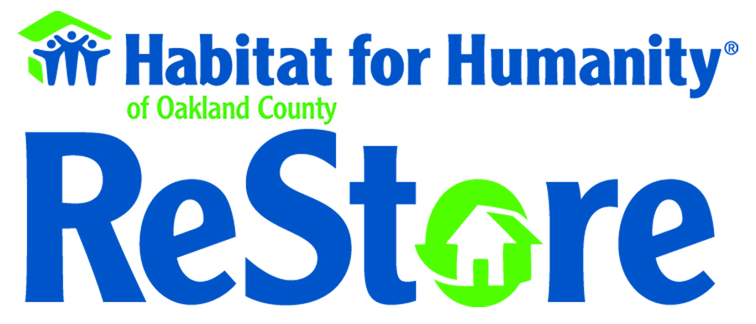
Now More Than Ever.
Help Build It!

ReStore Basics
Habitat ReStores are retail outlets that sell new and gently used donated goods from individuals, businesses, retailers, builders, distributors and manufacturers, which are then sold to the general public. The Habitat ReStores’ mission is to further the ministry of Habitat for Humanity by providing additional funding through the sale of merchandise so that Habitat affiliates can help more families build, renovate or repair their homes. Habitat ReStores benefit our local communities by:
- providing affordable merchandise;
- offering earth-friendly alternatives to divert waste from landfills; and
- providing employment and volunteer opportunities for members of our communities.

Most Habitat ReStores sell home improvement goods such as furniture, home accessories, building materials of all types, various appliances, and new paint at discount prices. The merchandise mix is dictated by what materials are readily available and what local laws dictate as resale materials. Habitat ReStore profits are considered undesignated funds, which means that they may be used for both program and administrative expenses. As with other social enterprises, Habitat ReStores are designed to make a profit; however, they are considered a “non-profit” business because all ReStore net-revenue goes towards the Habitat mission of eliminating poverty housing.

Habitat Oakland County ReStores
In April 2016, Habitat Oakland County re-acquired two ReStores – one located in Pontiac and one in Farmington Hills. The affiliate hired ReStore staff to manage the stores, including the call center and donation pick-up service line. The following categories represent the general merchandise mix at the Oakland County ReStores: building materials, furniture, electrical, home décor, tools/hardware, paint, appliances, plumbing, home goods, windows, doors, and cabinets.

Habitat Oakland County has set the following operational milestones/objectives for our ReStores:

- provide low-cost, quality home goods and products to residents in our communities;
- provide donors, shoppers and volunteers with a quality experience;
- recycle and reuse items/materials to divert over 200 tons of waste in landfills per year;
- generate dollars to supplement Habitat’s traditional fundraising efforts; and
- engage 100 Oakland County residents per year for ReStore volunteer opportunities.

Statement of Need
The lifeblood of every Habitat ReStore is a steady flow of quality donations driven by a deliberate and systematic procurement process and intake, pricing and merchandising.
Our needs at this time are;
- Business Donations; Retailers, Manufacturers of Home Goods, Distributors, Trades, Remodelers, Construction Companies, Cabinet Companies, Appliance Companies, any stores delivering appliances to homes to suggest to donate the older appliance! Making phone calls or visits to locations to donate product.
- Volunteers; we require 5-7 volunteers a day to operate our ReStores to flow the product from Intake to Merchandising.
- Customers; Shoppers! Home Owners, Trades, Remodelers, Contractors, exposure to ReStores in Farmington and Pontiac! Sharing the NEWS of our treasures.
- Truck Sources; donated services to help us pick up products, donate a truck, donate a truck for a week, contribute to pay for truck rental or leasing.
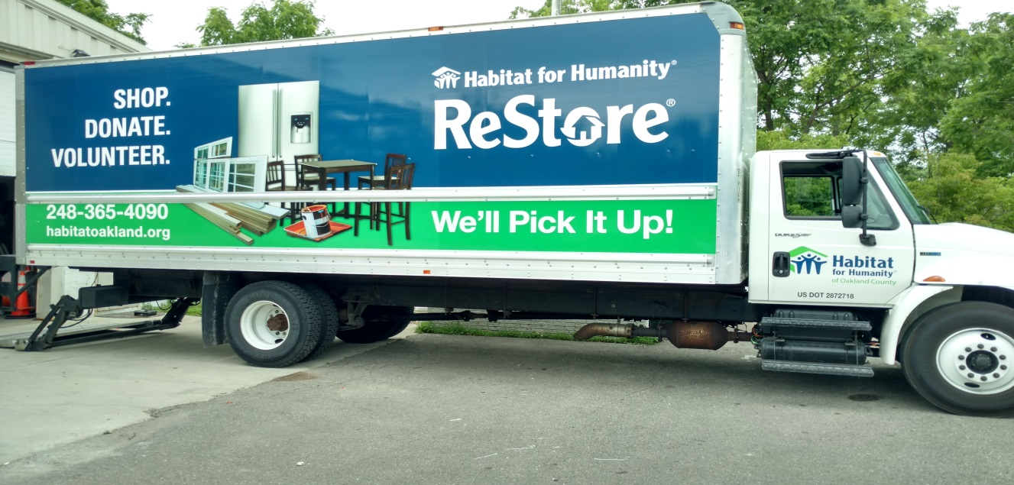
Pictured above is Habitat Oakland County’s current ReStore truck.
Donation Pick-Up Call Line: 248-365-4090 or go online to schedule at our website www.habitatoakland.org.
Locations
ReStore Pontiac
150 Osmun Street Phone: 248-338-8392
Pontiac, MI 48342 Hours: Thursday through Saturday, 10 a.m. to 5:30 p.m.

ReStore Farmington
28575 Grand River Ave. Phone: 248-442-2267
Farmington, MI 48336 Hours: Wednesday through Saturday, 10 a.m. to 5:30 p.m.

